**Piscinas Municipais de Paradela 12/08/2016**

**As 7 da tarde**

**A partir das 5 da tarde**

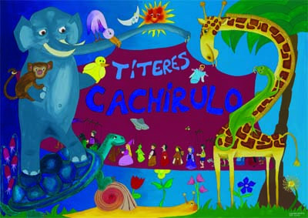

**PROGRAMA CULTURA NO CAMIÑO**

 [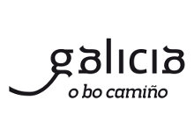](http://www.google.es/url?sa=i&rct=j&q=&esrc=s&source=images&cd=&cad=rja&uact=8&ved=0ahUKEwi03a3m3prNAhVCyRQKHSREBCAQjRwIBw&url=http://www.google.es/url?sa=i&rct=j&q=&esrc=s&source=images&cd=&cad=rja&uact=8&ved=&url=http%3A%2F%2Fwww.xunta.gal%2Fidentidade-corporativa%2Fmanual-o-bo-camino&psig=AFQjCNGveluPUM86Pa-guuvod1x6b8koEA&ust=1465554685510548&psig=AFQjCNGveluPUM86Pa-guuvod1x6b8koEA&ust=1465554685510548)   

# CONCELLO

# PARADELA